Drag and drop the archive set to the target db as you normally do. Click on the Migration Date drop down list.
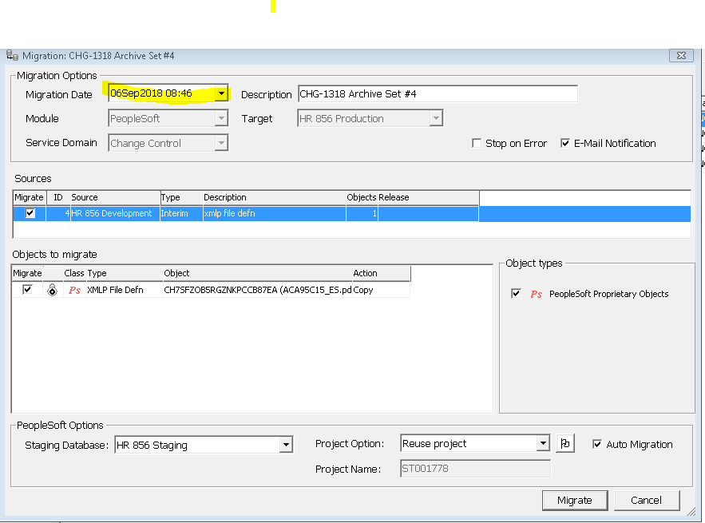

Change the date.
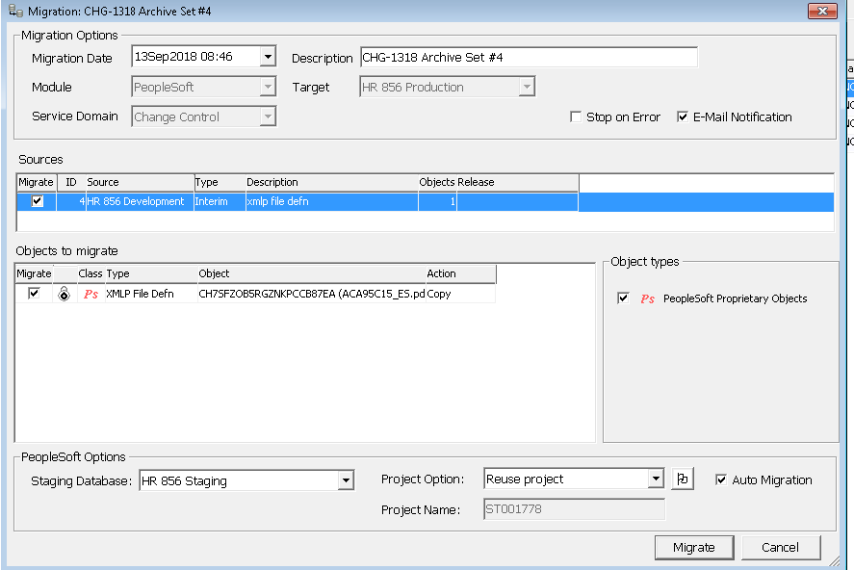

Stat have the ability to auto advance in 6.1.0. Open up the workflow | go to the step that you would like to auto-advance. Must configure at least a migration, activity or approval in order for the auto advance button to be enabled.

