Instructions for extending the Microsoft Store WMI attribute in ER 3.1H1

There is no report out of the box for the requested report on Microsoft Store applications in Windows 10.
Please read all of the instructions at least once before proceeding with any changes. This will ensure you understand what is happening and what to expect.
As the specific information requested is not collected during a discovery, a configuration change is required to the Configuration Manager in the extending of a WMI attribute, Win32_InstalledStoreProgram.
In the Configuration Manager select Configuration located under the System.
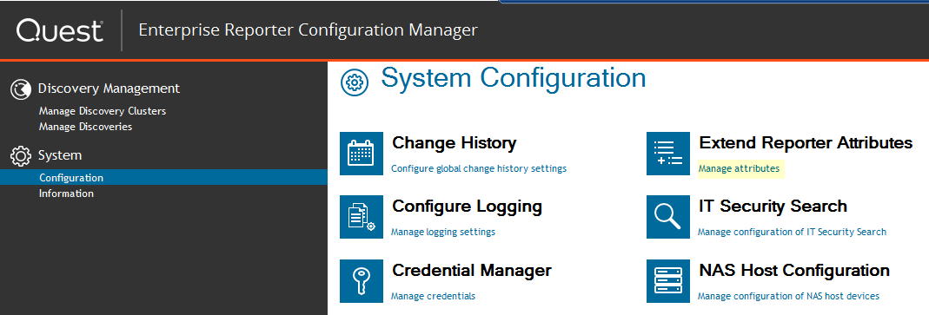

Next to extend the attributes collected by Enterprise Reporter select Manage attributes located under Extend Reporter Attributes.

A warning will pop-up. Click on the Yes button.
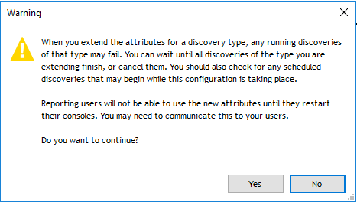

In the Extend Enterprise Reporter Attributes click on the Extend button in the Computer selection to extend the WMI attributes.
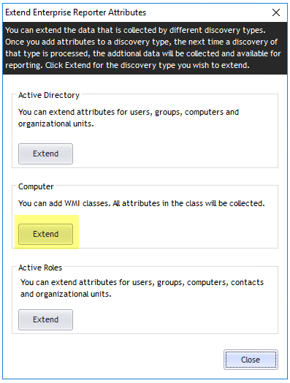

Next click on the Add button and browse down and select the Win32_InstalledStoreProgram located in the \root\CIMV2 class. Once you select and expand the CIMV2 class you will need to browse down to find the Win32_InstalledStoreProgram. This WMI class contains information on the applications downloaded from the Store.
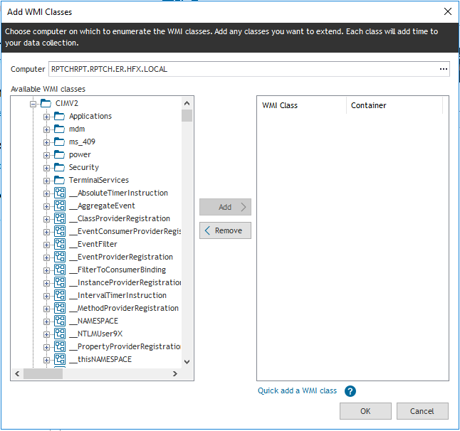

Select the Win32_InstalledStoreProgram and click on add.
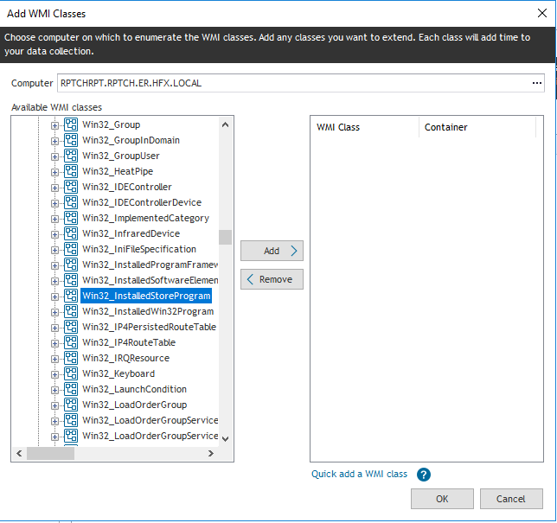

The class has been selected and now click on the OK button.
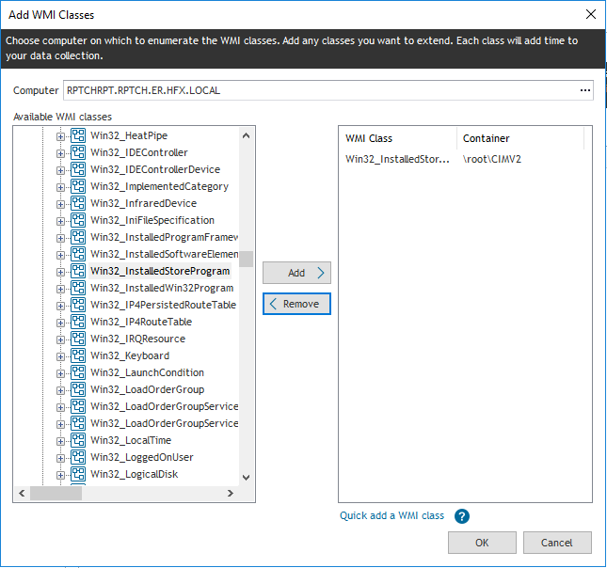

It will take a moment or two and the Extend Enterprise Reporter Attributes dialog will appear listing the extended WMI class. Click on the OK button.
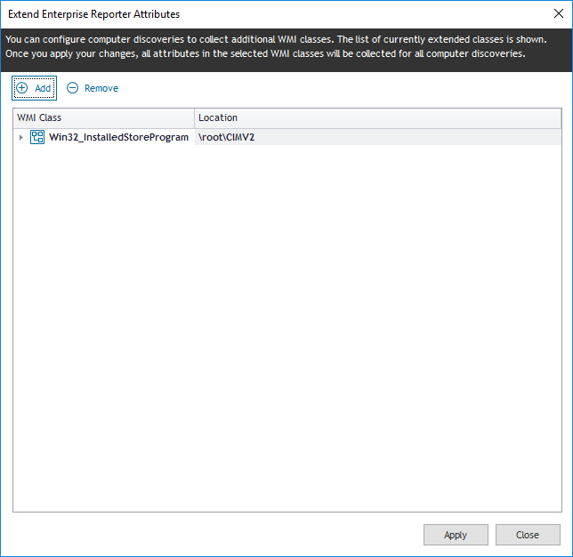

A dialog will appear giving a status of the extension of the attribute. Once it has complete click on the Close button.
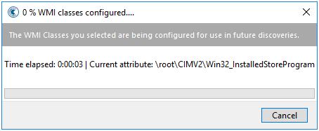

You are now back to the opening dialog so click on the Close button.
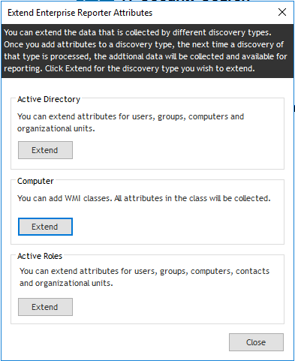

Now create a new discovery and select only those computers you wish to know the Microsoft Store information for. This will ensure you only select those systems you want to the report on and will run faster than selecting all of the server and/or computers in your domain(s).
In this discovery select the Extended WMI Entries option as highlighted below. This will execute the necessary code to retrieve the WMI setting for the systems selected.
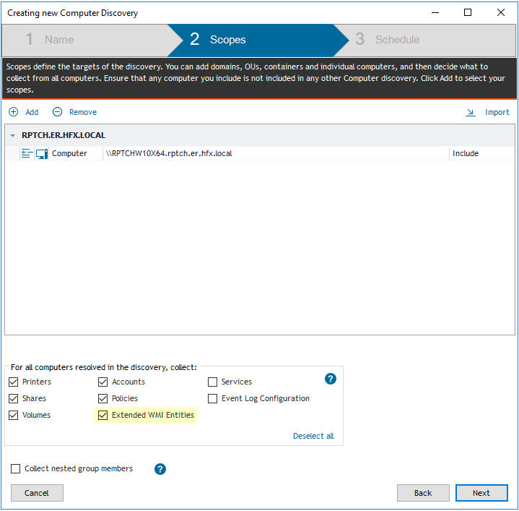

Before working with any of the reports and if you have the Report Manager open you will need close and re-open the Report Manager. The reason for this is to allow the new report template data for the WMI to be included in the Report Manager. If you did not close and reopen Report Manager and modify a report then the WMI data will not be available.
It would be easier to dump the data to a CSV file by creating a new report and including the extended WMI attributes. This way you could use say Excel to sort on a specific program that has been down loaded.
You will not be able to use the Installed Software Information report that currently exists in the ER Library as it has been configured without the newly extended attributes. Therefore you will need to create a new report. You would need to do this anyway if you want to export to CSV.
In Report Manager and under My Reports create a new report and give it a name say Microsoft Store. Fill in the other inform as needed.
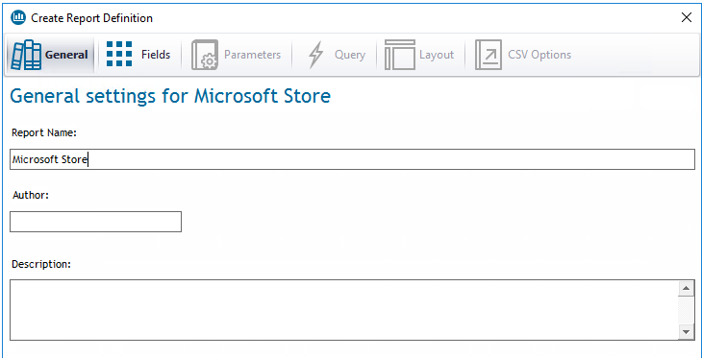

Click on the Fields button then select Report Type and then expand Computer WMI Extension and select the WMI.
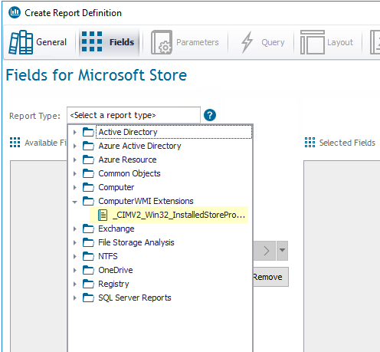

This will add the computer info and the WMI info. To see the WMI info you need to scroll down in the left window.
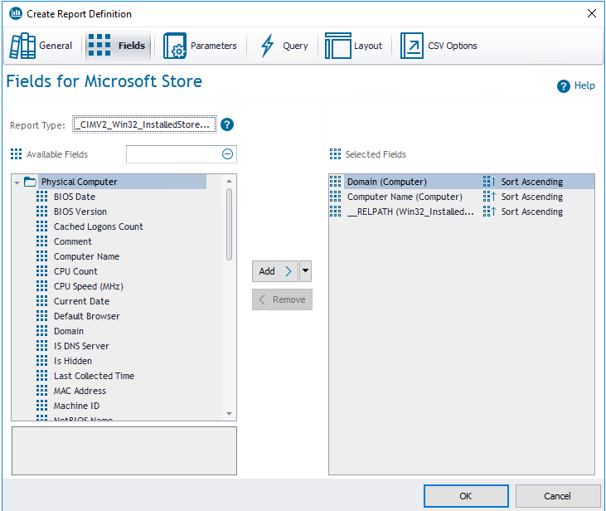
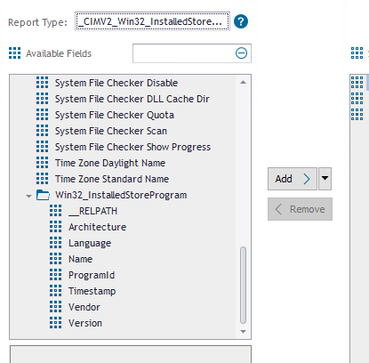

Select the fields you want to have displayed and click the Add button to move them to the right window of the dialog.
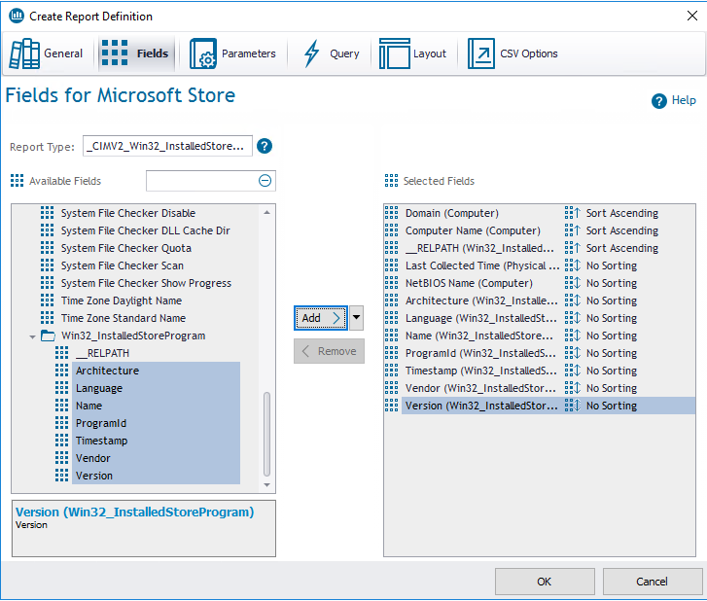

At this point you can save by clicking the OK button and then export to CSV. You could also continue on by selecting the layout and formatting a report. The formats are basic and will need some work. Please see the Report Designer User Guide for information on formatting a report. You could also use another report and copy and paste item for one to another to get the look you want.

If you select the OK button the report will be save and you can edit it later. You will get a popup message informing you the report can only be exported to CSV. Click on Yes to save.
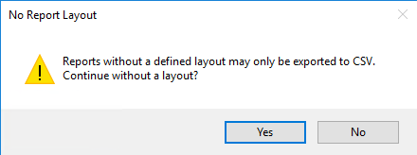

Now click on the report in My Reports and click on Export to CSV. You will be asked where to store the report. Select a location and then you will be asked if you want to open the report. Select Yes.
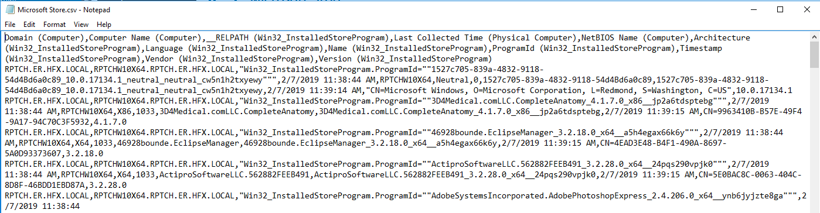

You can then modify the report to remove any info or add any addition fields. You can also add a parameter to the report say that is based on a program name and only have computers that have that software installed be displayed.

