Local Computer that have any of the Domain Groups without Members

- Go to ‘Domain Groups without Members’ report and Click ‘Edit report’
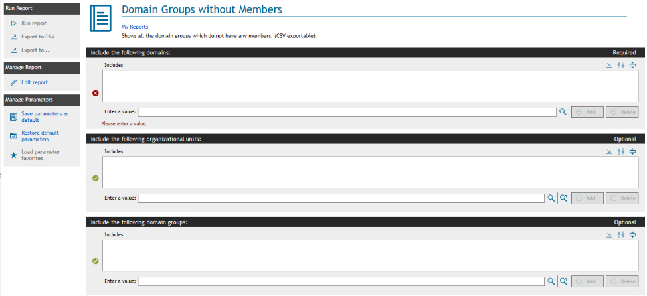

- Go to ‘CSV Options’ tab on the Edit Report Definition. Uncheck all fields except Account Name (Group). Also, uncheck ‘Include column headers in exported file’.
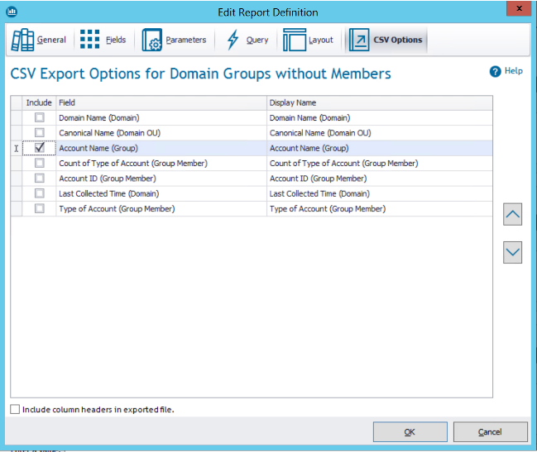

- Click ok to save the changes.
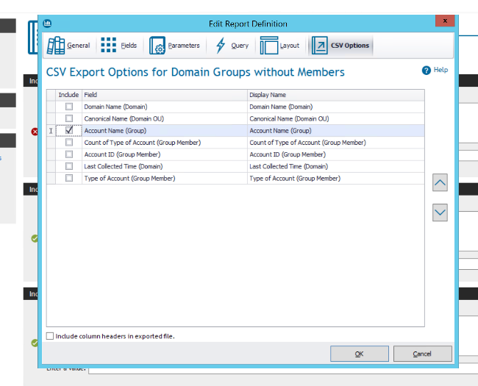

- Enter the domain name for which to run the report. Click ‘Export to CSV’ on the ‘Domain Groups without Members’ to export all the domain groups accounts without members in the CSV file
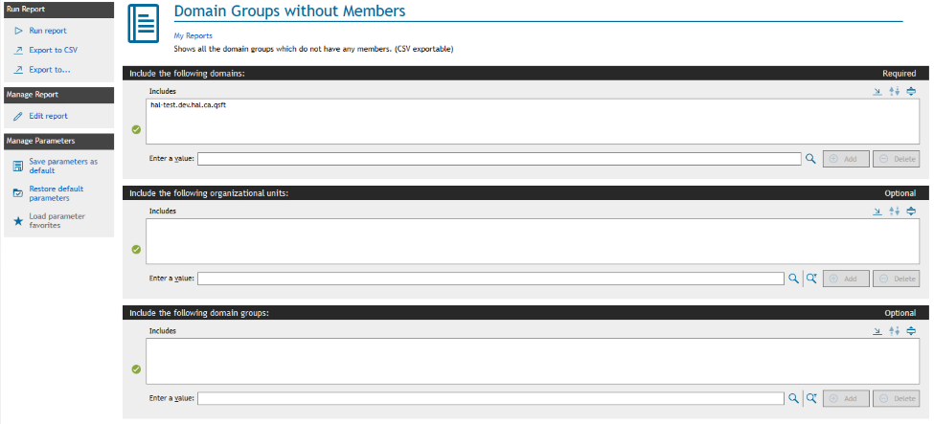

- Provide the folder path to save the file and click Save.
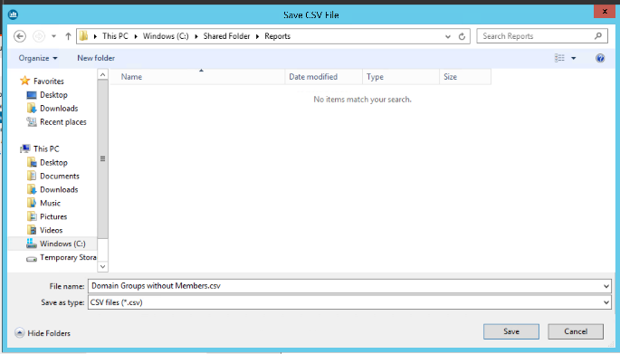

- Go to ‘Local Groups and Members’ report and Edit the report.
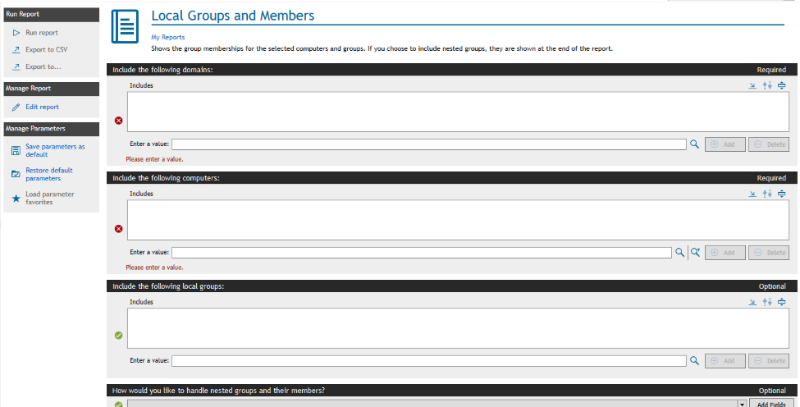

- Click on the ‘Parameters’ tab and click on ‘Add’ button.
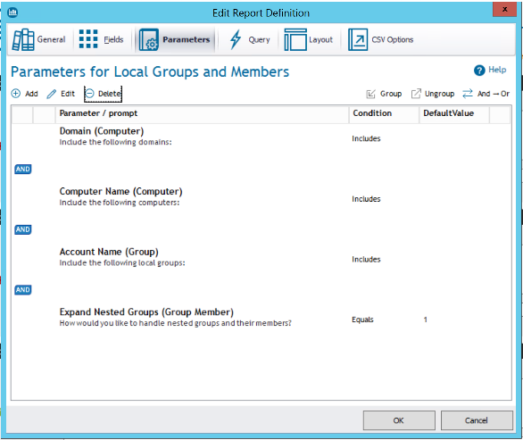

- Add an optional parameter by providing following information on the Create parameter page:
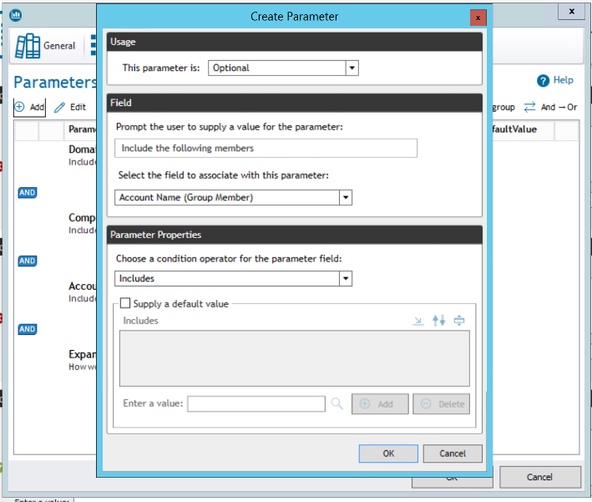

- Click ok to add the parameter and again click ok to save the changes in the ‘Local Groups and Members’ report. New parameter will be added as a parameter.
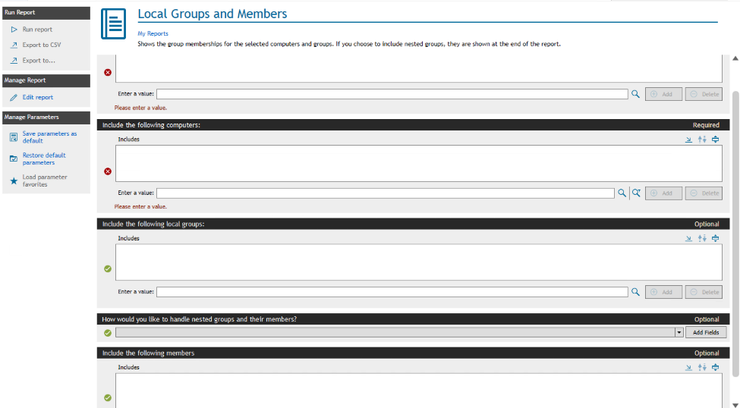

- Click on the import button on the newly added parameter.
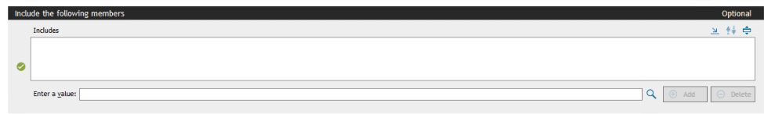

- Provide the path of the CSV file for ‘Domain Groups without Members’ saved in step 6. Select ‘All Files (*.*)’ in the file type.
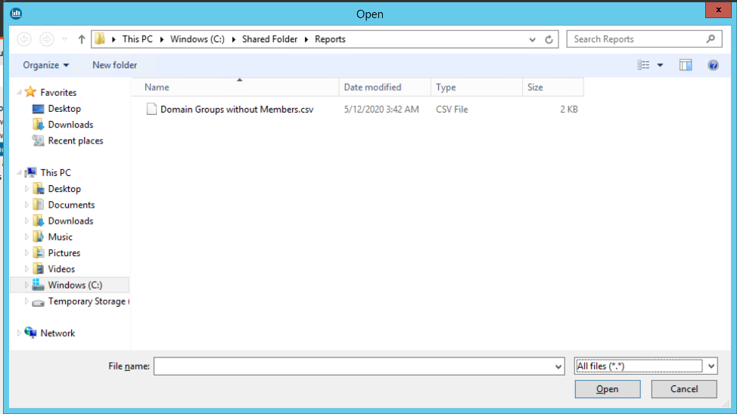

- Click Open to import all the accounts in the parameter.
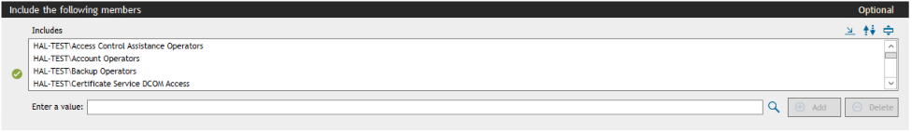

- Provide Domain name and computer name (if you want to search all local computers enter ‘*’) in the parameters.
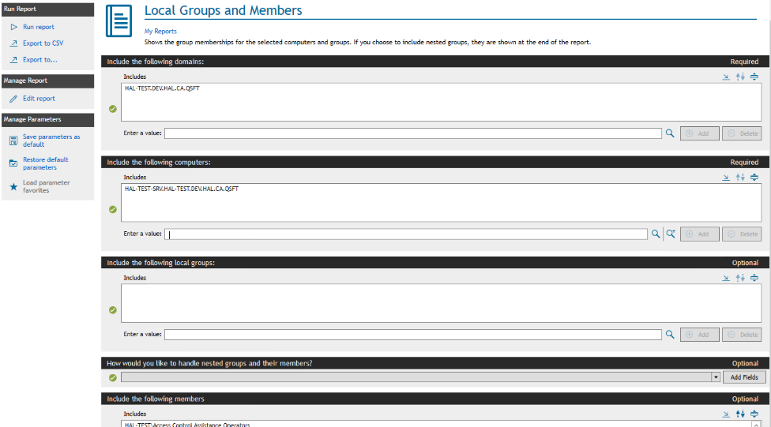

- Run the report to get all the local computers where imported accounts (i.e. Domain Groups without Members) are the member of the local groups.

