- Need the Export button enabled to extract the below details to get the extract of the below projects.
Navigation File Open Project (search by project code).

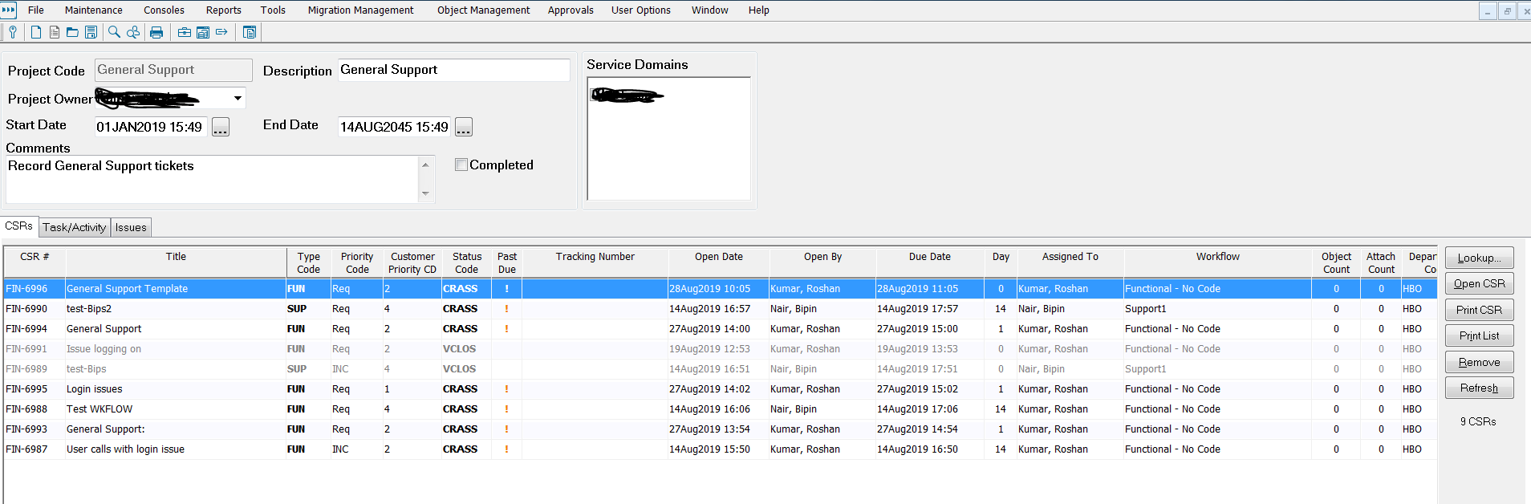

1] We need a option to extract the below details in the Excel sheet. Currently there is no option to export the list.
2] We also need a summarized column marked in yellow Total Est.hrs /Act.hrs in screenshot 1 so that we know for Each CSR what was the total time taken to implement that CSR.

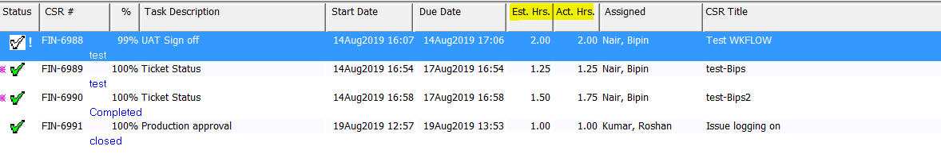
Reason:
This can help the customer to evaluate the work effort and estimated time taken to complete the project.Currently customer is not able to evaluate the Actual hrs taken to implement
Certain projects. By achieving this we can do a excel reporting and find out how time is estimated and taken for certain activity.

