Roles

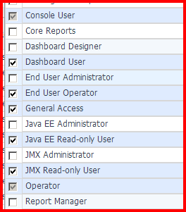

Error while access the DB Tier in the SOC dashboard…!
