How to create a Domain User report for users created in the last xx days.
Select the Domain Users report from the Active Directory library and select copy.
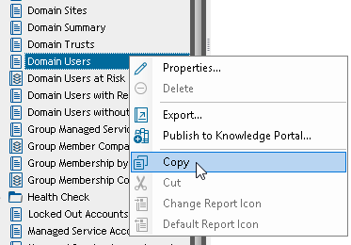

Paste it into My Reports.
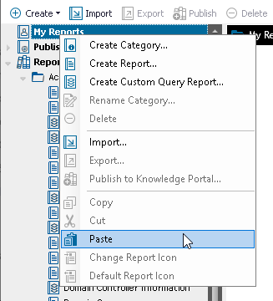

In My Reports select Domain Users and then select Edit report.
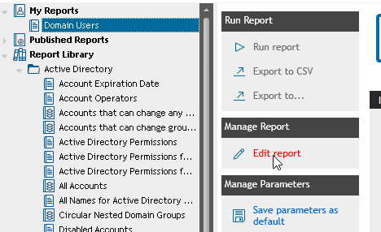

Change the Report name to something which explains the report such as seen below. In addition, change the description to more useful information.
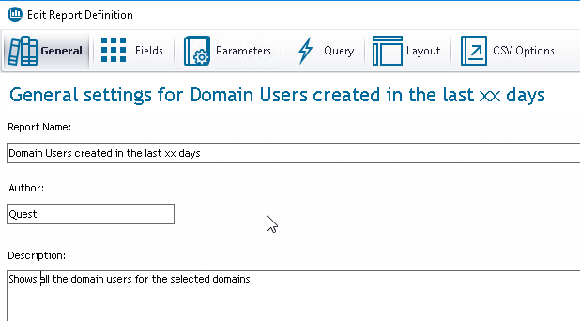

If you select the Fields you will notice that the field we need to check and make a parameter with is already in the Selected Fields, so we don’t need to add it.
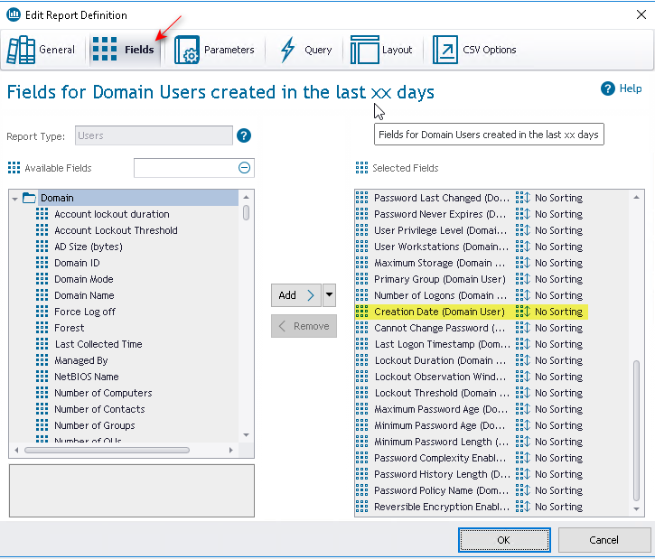

Select the Parameters as you need to add the Creation Date as a parameter for the report. Click on the Add button to add a new parameter.
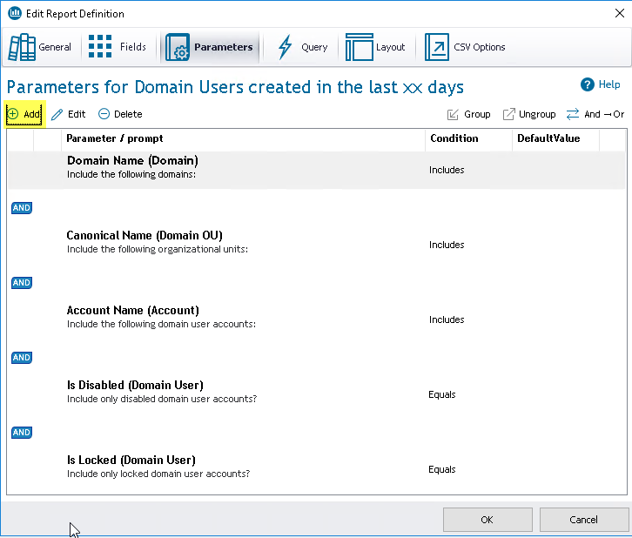
You will get a warning message as seen below. Just click on Yes to proceed.
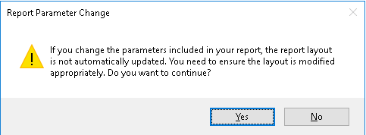

The create parameter dialog opens and is ready for you to make the changes to add the new parameter.
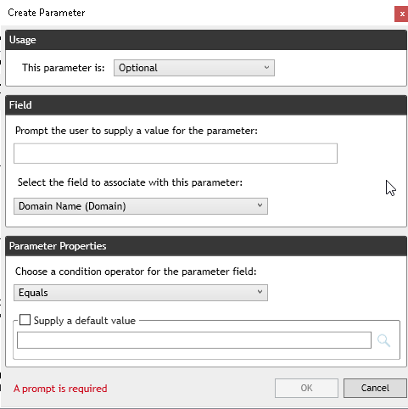

In the Usage part of the dialog leave the Usage set to Optional.
In the Field part of the dialog enter a label for the new parameter such as in the example below. Note that you can come back and edit this value at any time. In the Select the field to associate with this parameter, click on the drop-down box and search for the Creation Date field.
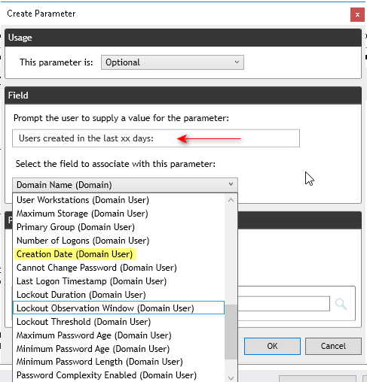

The Field info is now available for the parameter.
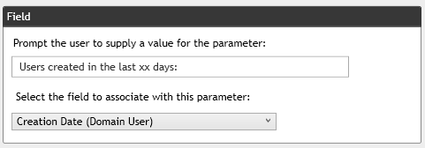

The last thing that needs to be selected for the parameter is the Parameter Properties. Select the drop-down box and scroll down and find In the Past condition operator.
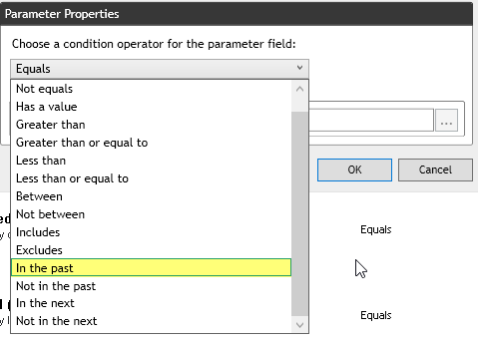

As there is no preset for the value leave it blank.
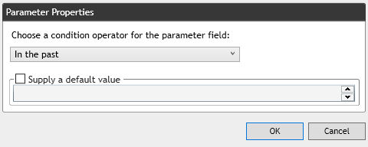

The parameter is now ready to be saved and used. Click OK to save the parameter.
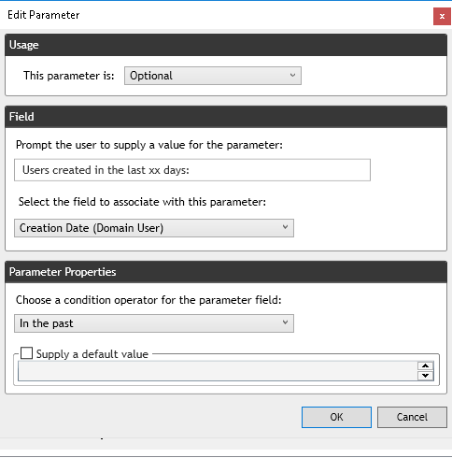

Note that the parameter has been added to the parameter list. Click Ok to save the changes to the report.
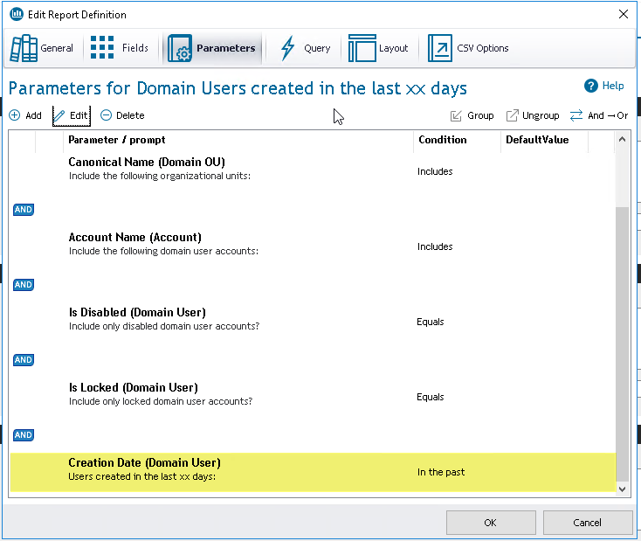

The report is now ready for testing. Select a domain and enter the number of days in the new parameter and click on Run report. Note that if you don’t need or use some of the other parameters in the report you can remove then on the Parameters page and they will not be displayed on the report form.
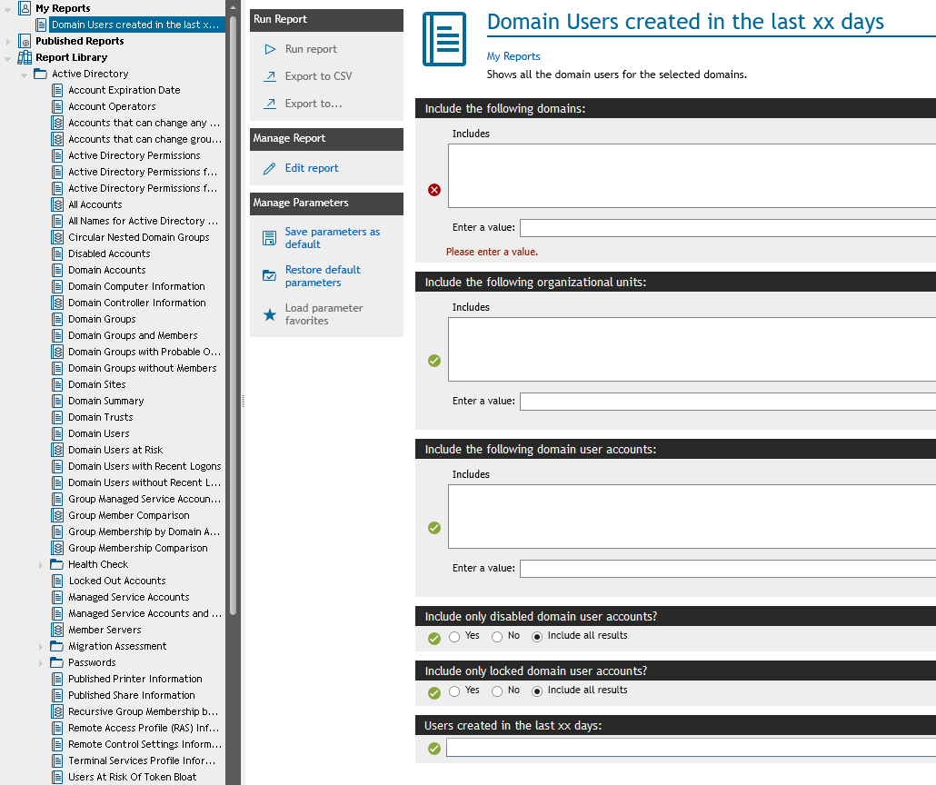

You could also hide the parameter which will remove it from the parameter list but not remove it from the report. You could unhide it in the future if you want it back. If you hide the parameter you must select a default value such as No for the parameter.
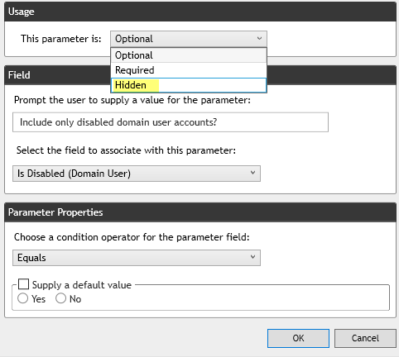

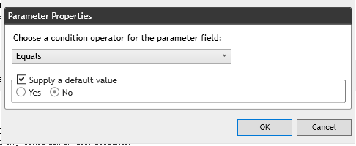

Here we see that two parameters are hidden.
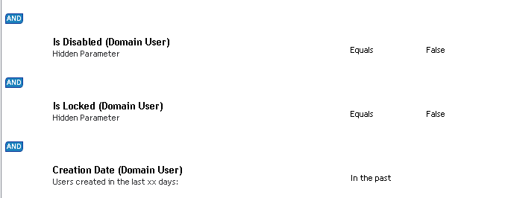

The report now has less parameters which are not used.
